

**MAD CONSTRUCTION**

by Jun Jie, Yu Xuan and Thiha Aung Set

1. **Description**

# Our app aims to help users focus on their tasks. The user can use our app to set a time period in which their sole goal is to complete their task, whether it is to study, exercise or be productive in any way. This app is a tool that can be used to tackle problems with procrastination and phone addiction, which many people in our generation suffer from due to the ease of access to our mobile devices. Users can also keep progress of the time they spend focusing on their tasks on a monthly basis.

# 

# 

# **Features**

* 1. A log in/ sign up page  
     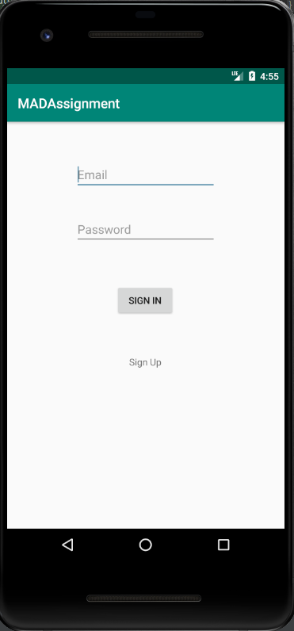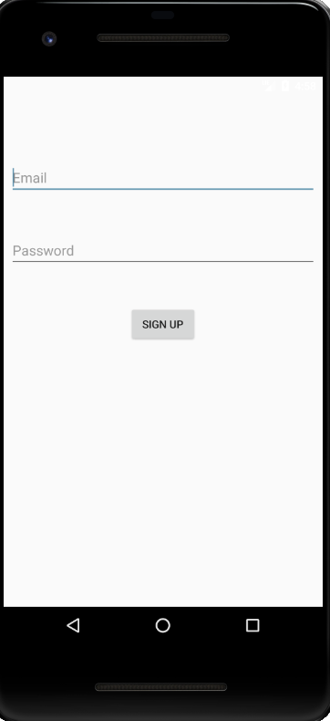  
     This page is what users see when they first open the app. They can choose to log in if they have an existing account, or sign up as a new user. The data is collected and stored in a Firebase database where the app can authenticate the user’s credentials.
  2. Navigation Sidebar  
     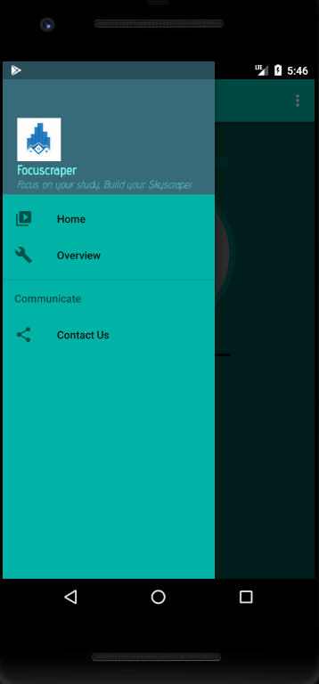  
     This is a navigational bar that the user can use to navigate between different pages. ‘Home’ leads to the countdown timer, while ‘Overview’ leads the user to a graph of records. ‘Contact Us’ shows the information of the developers of the app.
  3. Starting the Timer   
     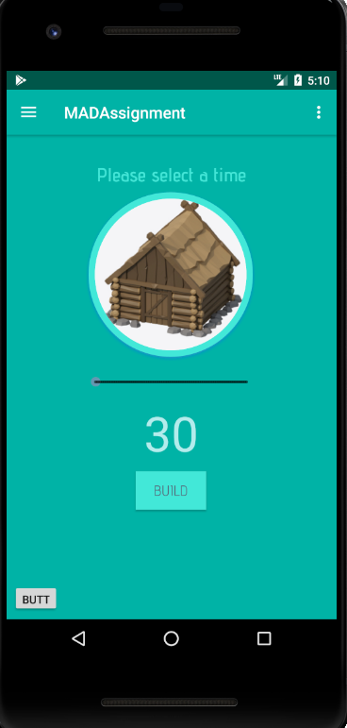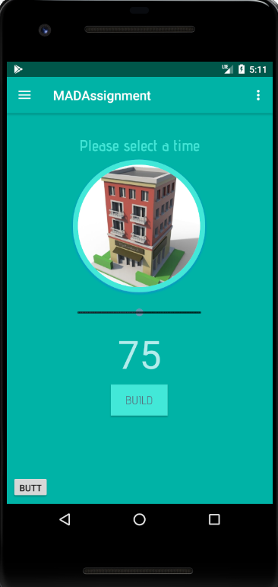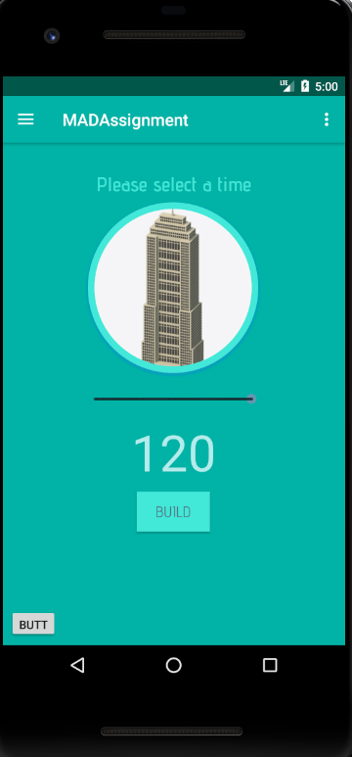  
       
     Once logged in, a page with a circular icon and a slider will appear. The slider can be shifted to the desired number of minutes the user wants the timer to countdown, ranging from 30 minutes to 120 minutes. This is the amount of time the countdown timer will start at, and the user can simply tap the ‘BUILD’ button to initiate the timer. The icon contains different pictures of buildings. The icon will change according to the amount of time that the slider is selecting, with the building being a better one if the user chooses a longer time.
  4. Countdown  
     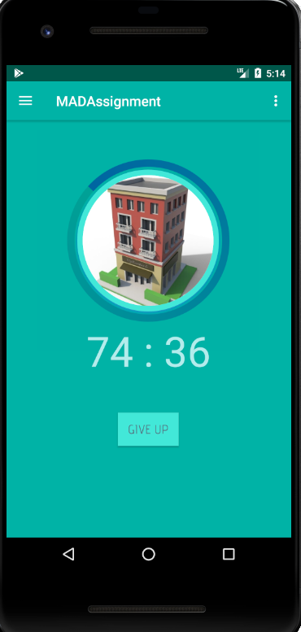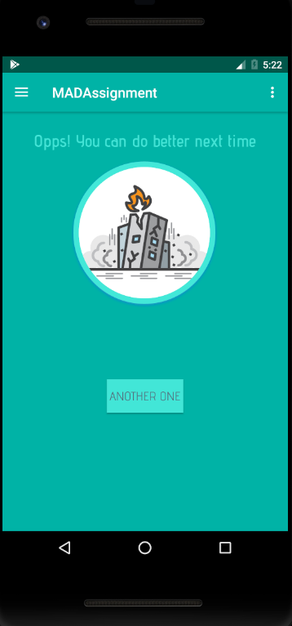  
       
     When the user presses ‘BUILD’, the countdown timer starts with the chosen time. The icon will also show the corresponding building that will be “built” at the end of the timer. There is also a ‘GIVE UP’ button that the user can click if they choose to stop concentrating.   
       
     The ‘GIVE UP’ button brings the user to a page that shows a destroyed building in the circle, showing the user that since they gave up, their building could not be completed and that they have failed to focus for the chosen time.   
       
       
       
       
       
       
       
       
     However if the user manages to stay focused and finish the countdown without giving up, they will be alerted that the time has been completed.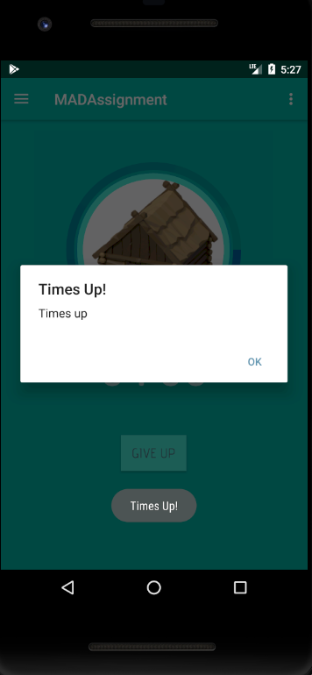
  5. Overview   
     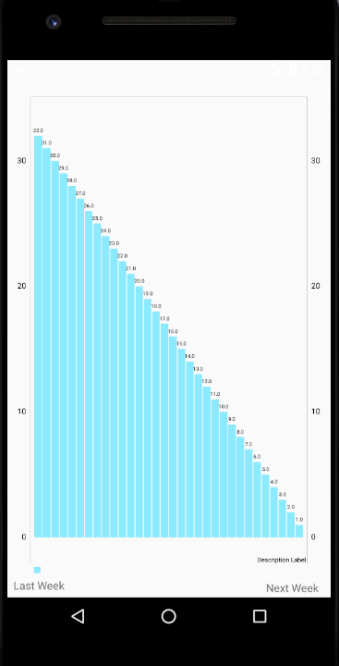  
     When the user selects ‘Overview’ in the navigation bar, a graph appears, which displays the number of hours the user has focused for in the month. It appears according to the number of days in the month and the user can also switch the months using the two buttons at the bottom. This feature helps users track their progress and motivate themselves by seeing how much they have achieved by focusing through the app.